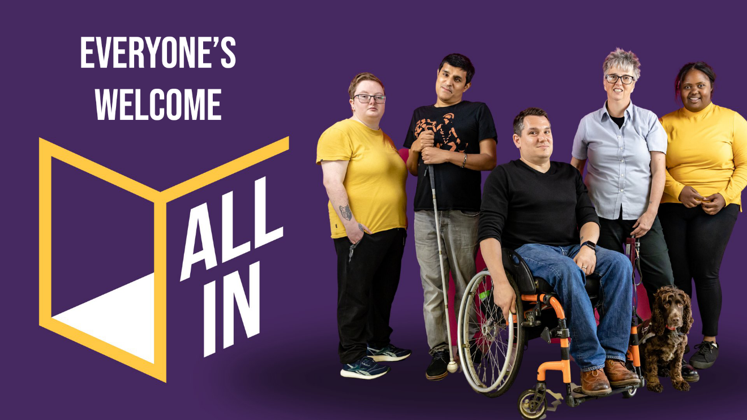

Expressions of Interest to become a member of the UK and Ireland **All In** Advisory Group (AIAG)

**Recruitment Information Booklet**

**Contents**

About All In 3

Background 3

What will the scheme do? 3

About the All In Advisory Group 5

Who we’re looking for 7

How the application process works 8

What to expect at the group meetings 10

When and where? 10

What will happen in a typical meeting? 10

Contact 10

# About All In

## 

## Background

[All In](https://allin.online/about-all-in/) is a new access scheme in development in the UK and Ireland to improve accessibility in arts, creativity and culture for people who identify as D/deaf, disabled, and/or neurodivergent.

It is being developed by people with disabilities for people with disabilities, who want to help creative and cultural organisations improve access, remove barriers and welcome more people with access requirements through their doors. This includes theatres, museums, galleries, festivals, libraries and more.

It is based on the [Hynt Access Scheme](https://www.hynt.co.uk/en/about/what-is/) in Wales, which has run for the past 10 years with significant impact, with 29,866 card users and 41 venues participating.

All In is a partnership between Arts Council England (ACE), Arts Council of Northern Ireland (ACNI), Arts Council of Wales (ACW),and Creative Scotland (CS) As of October 2024, the Arts Council of Ireland (ACI) will join **as a founding partner** to extend the project to cover all of Ireland in its remit.

**This project is, and will continue to be, disabled-led and inclusive, reflecting the needs of the groups we seek to serve.**

## 

## What will the scheme do?

The scheme is still in development with an initial pilot planned in the UK later this year. Features of the UK and Ireland wide scheme being explored include:

* The UK and Ireland’s first accessibility standards for creativity and culture, to create consistency and quality for people with disabilities.
* An online digital membership scheme and website, where people with disabilities can find information about accessible performances, venues and sign up to share their access needs.
* The ability to integrate with the major ticket booking systems, allowing people with disabilities to book tickets, and share their access requirements with participating organisations.
* Data and analysis for the arts sector on engagement trends for people with disabilities, which will inform the sector to help grow audiences and drive the provision of improved access
* Support and skills development for organisations, featuring resources on how to develop best practice in delivering accessible programming, events and spaces.
* An accreditation programme for participating venues.

To date, the All In Advisory Group (AIAG) has supported the development of this scheme by bringing lived experience and sector expertise to the decision-making process for the UK wide access scheme and providing viewpoints from across the four UK Nations: England, Northern Ireland, Scotland and Wales.

Given that Ireland is now joining this scheme and will be contributing to that development process, we want to recruit two Irish based representatives to sit on this important Advisory Group and offer new perspectives from Ireland to the team.

# About the All In Advisory Group

The All In Advisory Group (AIAG) sits outside of the five partner organisations and meets every three months (4 times per year) to advise the project team on a range of topics. Membership of AIAG will be for a minimum of 12 months initially.

**This is a remunerated role. Members of the AIAG will receive €225 per meeting they attend.**

The responsibilities of the group are to:

1. Advise the project team as it seeks to implement the project, this could include, but is not limited to, advice on:

* Planning and timelines
* Technical specifications and challenges
* Barriers faced by disabled, D/deaf and neurodivergent audiences and visitors to ticketed cultural events
* Equality Objectives and Action Plans
* Budget decisions
* Advocacy & Communications
* Evaluation
* Any other relevant topics discussed by the group

1. Review and monitor the impact of the project team’s decisions and other actions in these matters
2. Provide expert insight and sector knowledge
3. Play an advocacy role for the scheme and its promotion in external facing communication.

**Representation on an Irish Expert Advisory Group**

As well as representing Ireland on the All In Advisory Group, you will also sit on an Irish Expert Advisory Group. This group is being established to support useful exchange of knowledge and insights between the Irish disability, arts and cultural sectors and the UK based All In lead team. You will play a key role as a point of liaison in this regard. This Expert Advisory Group shall meet three times a year.

# Who we’re looking for

Being a member of the All In Advisory Group is an interesting and important role that will allow you to make a real impact to accessibility in the creative and cultural sector. If you’re passionate about widening access to creativity and culture, we want to hear from you.

We would like to attract people with a range of skills, experiences and voices who can demonstrate:

* Experience and knowledge of the creative and cultural sector, whether through their own creative practice, freelance work or work within an arts and culture organisation
* Knowledge and/or lived experience of the barriers faced by audiences and visitors to ticketed events
* Involvement in creative and/or access/disability focused networks. This might include knowledge about access membership schemes and/or websites and databases
* A commitment to championing inclusion and relevance within arts, culture and creativity.

**As this project is disabled-led, we are only accepting applications from people who identify as D/deaf, disabled and/or neurodivergent, or who have a long-term condition. In this instance we are looking specifically for people with disabilities who live in the Republic of Ireland.**

We are looking for people with enthusiasm and cultural knowledge, who are open to new ideas and able to think through policies and decisions carefully and fairly.

You’ll be supported by the project team as you join the All In Advisory Group.

You don’t need to have been a member of a board or advisory group before, and you won’t be thrown in the deep end. We don’t expect you to come to the role knowing the ins and outs of everything we do.

# How the application process works

1. **Application**

Send us a copy of your CV with a covering letter outlining:

* Why you’re interested in serving on the All In Advisory Group
* Any relevant skills, interests or experiences (professional and/or personal).

Alternatively, you can submit an audio CV and application in spoken English, or a video CV and cover letter in spoken English or ISL. This should include the information above and be no longer than 10 minutes in total.

Please send your application to the Project Manager: Monica Corcoran, at

allin@artscouncil.ie

**The deadline for applications is 12 November 2024.**

1. **Shortlist**

A small selection panel comprising Senior Project Managers from the UK and Ireland (tbc) will shortlist the candidates they would like to invite to an interview.

**Interviews will be held on 28 and/ or 29 November 2024**

1. **Interview**

This is a relaxed interview, and a great opportunity to learn more about the role from the panel. The interviews will be held **online** using the Microsoft Teams platform.

We’ll send you the topics we’d like to discuss beforehand. We’re interested in hearing about:

* Why you’ve applied for the role
* What skills, interests or experiences (professional and/or personal) you could bring to the group
* The topics that are important to you, and issues you would like to give voice to on the group
* How you will contribute to our commitment to widening access through All In

The interview is your chance to meet us and ask any questions about the work we’re doing on All In and the role of lead agency Arts Council England and its partners, including Arts Council Ireland.

1. **Selection and Appointment**

Preferred candidates will be recommended to the project partners’ steering group for appointment in **December 2024**.

We will notify candidates of the outcome as soon as possible after the meeting.

# What to expect at the group meetings

## When and where?

Members attend a meeting every three months. Irish members would join from January 2024.

We know that people lead busy lives and juggle lots of different responsibilities, so we will send out a list of upcoming meeting dates and times ahead of time and try to be as flexible as possible.

**The next meeting of the AIAG will be on Friday 17 January 2025**

Meetings will take place online using Microsoft Teams and last for 2 hours. We will make sure any access arrangements are in place for the meetings.

## What will happen in a typical meeting?

The AIAG will play a vital role in reviewing and influencing the project team’s plans and decisions. Here’s what you can expect at the meeting:

* The Chair will lead the discussion of each agenda item
* The Senior Project Manager(s) will updateon the progress of the project and anything else relevant to the meeting from the partner organisations
* Members of staff from the project team may attend for specific items to present and answer group will be asked to take a collective decision
* There’ll be the opportunity to hear directly from key stakeholders and funded organisations on the impact of the project
* The group will be tasked to make recommendations to the project team
* At each meeting, all group members will be asked to declare any conflicts of interest in relation to agenda items.

Every meeting ends with a quick wrap up of what we’ve covered, making sure nothing’s been left unsaid.

# Contact

email: [allin@artscouncil.ie](mailto:allin@artscouncil.ie)

enquiries: 087 205 5932